ASP.NET Core Web API – Hands-on 4
Aim: To implement the PUT action method in an ASP.NET Core Web API to update employee details using the FromBody attribute, validate employee IDs, and return appropriate HTTP responses using ActionResult
Theory:
- PUT Method: The PUT method is used to update an existing resource on the server.
- FromBody Attribute: The FromBody attribute binds the incoming JSON request body to a C# model object.
- ActionResult: ActionResult allows the API to return different HTTP responses such as 200 OK and 400 Bad Request.
Procedure:
- Created a new ASP.NET Core Web API project named FirstWebApi.
- Configured Swagger in Program.cs.
- Created the model classes Employee, Department, and Skill.
- Created EmployeeController.
- Created a static list of employees with hardcoded data.
- Implemented the GET action method to retrieve employee details.
- Implemented the PUT action method using the [FromBody] attribute to receive employee data.
- Checked whether the employee ID is less than or equal to zero and returned BadRequest("Invalid employee id").
- Checked whether the employee ID exists in the hardcoded employee list. If not found, returned BadRequest("Invalid employee id").
- Updated the employee details using the JSON request body and returned the updated employee using ActionResult.
- Executed the application and opened Swagger.
- Tested the PUT API using a valid employee ID and verified that the employee details were updated successfully.
- Tested the PUT API using an invalid employee ID and verified that 400 Bad Request with the message "Invalid employee id" was returned.

EmployeeController.cs:
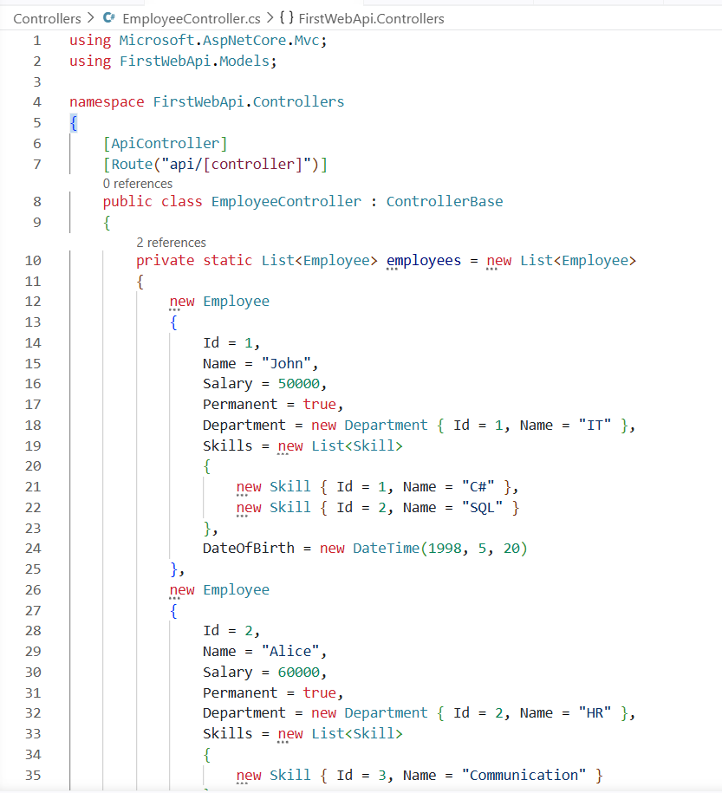
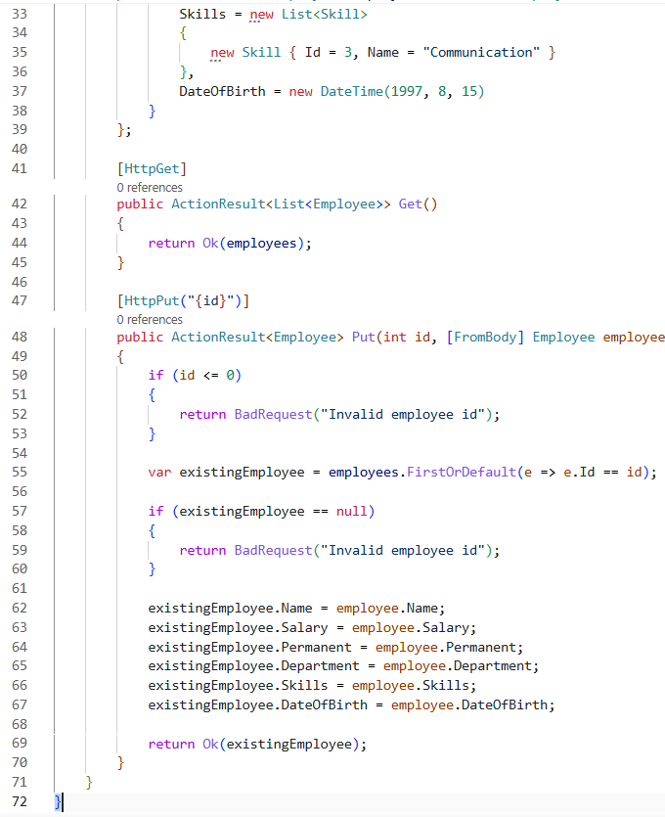

Output:
Valid Request:
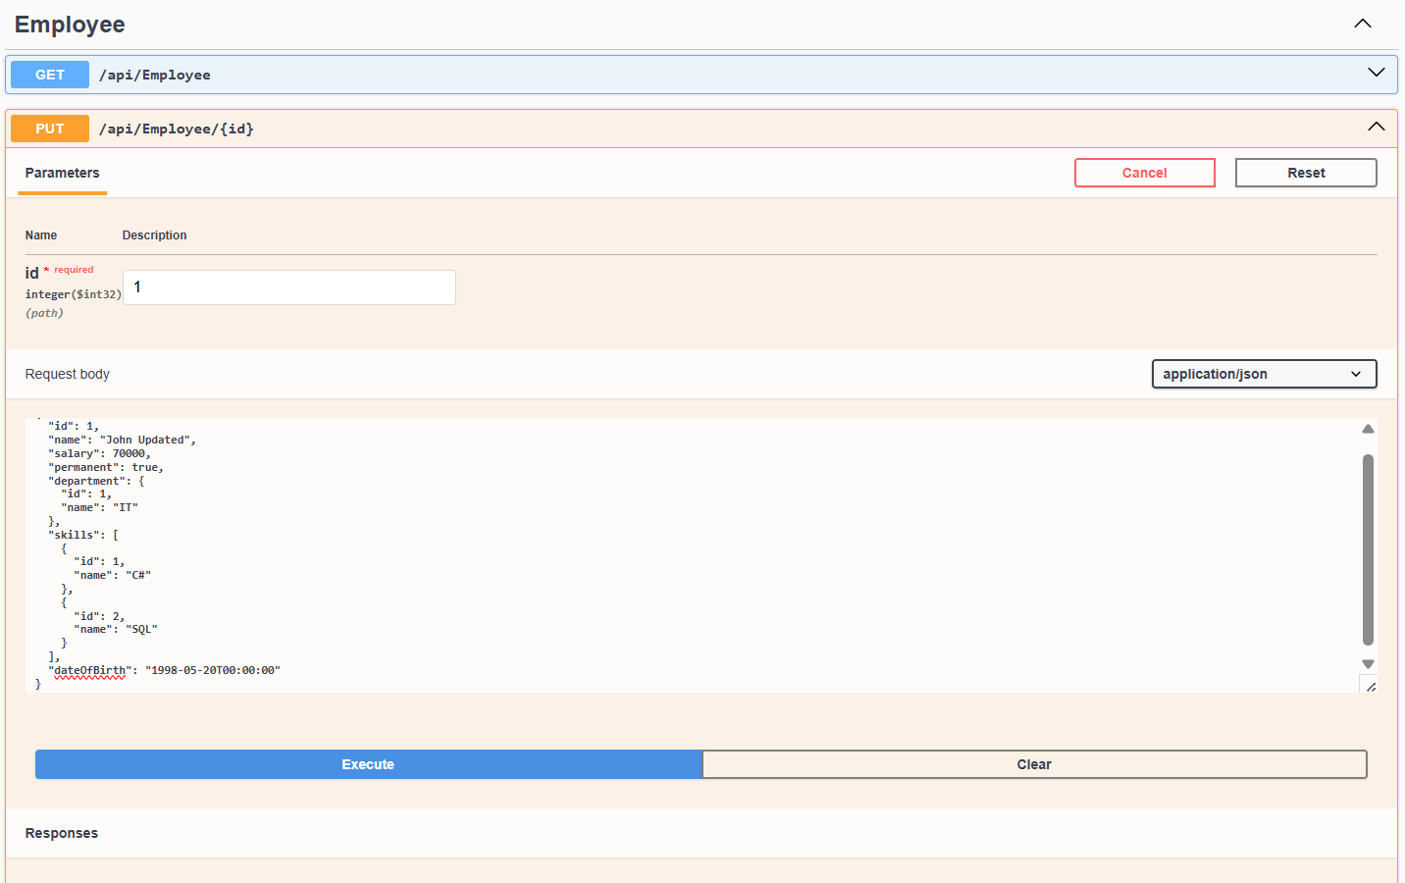
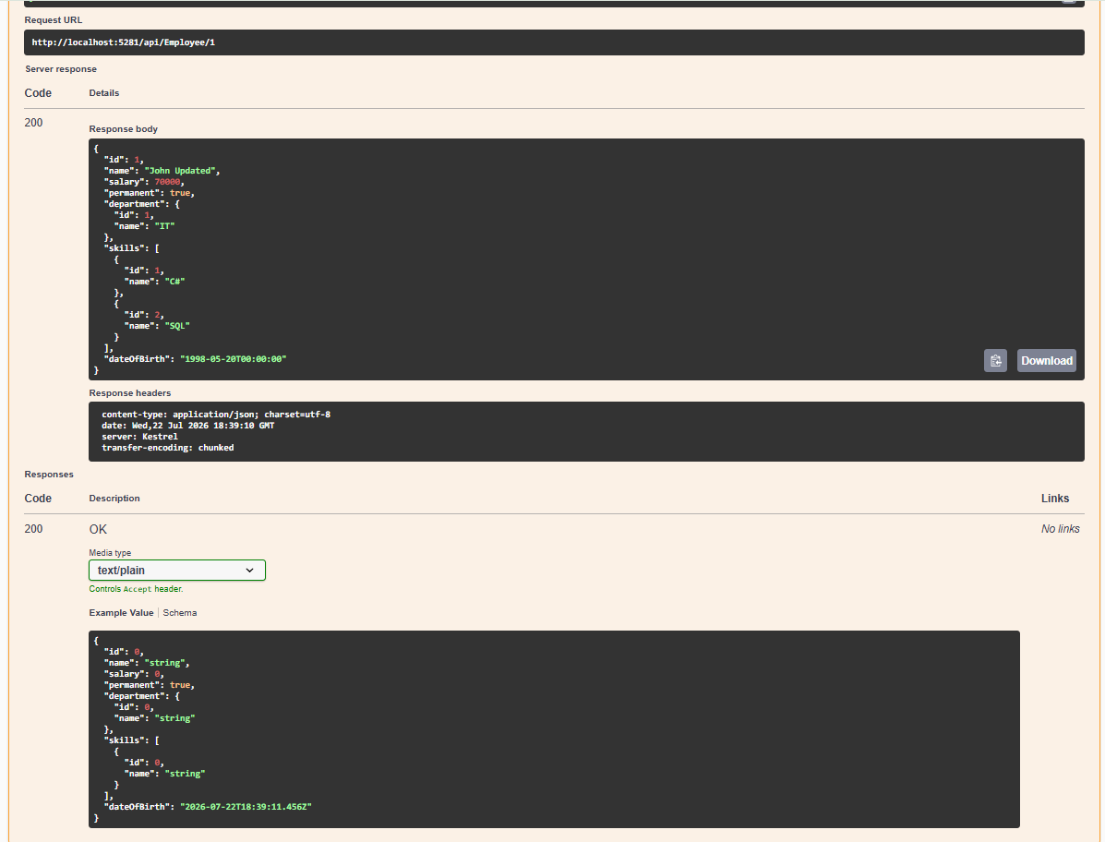

Invalid Request:
